Values: VDD: 12, freq:60, pmax: 0.15, Q: 10

1 cijfer na komma

Begin bij pmax: (Vdd)^2/2R

* 12^2/2r = 0.15, r = 480 ohm
* 0.15 waarde mag niet overschreden worden
* Hoger voor 5% range
* Standaardwaarde 510ohm 5% 🡪 pmax = 0.148607-0.134454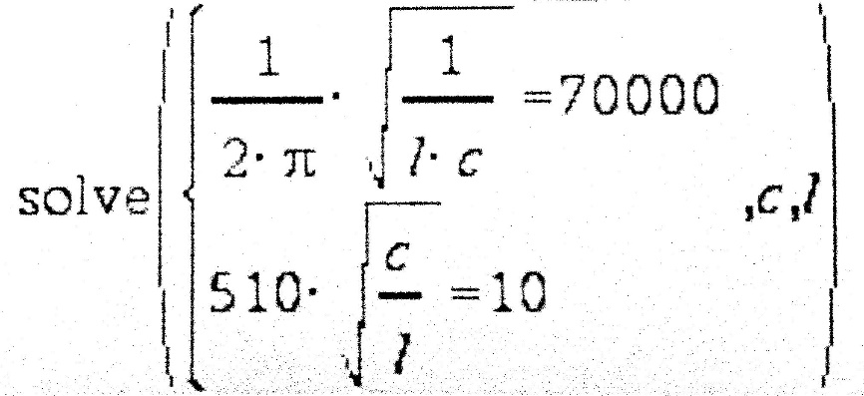
* C = 4.458 \* 10^-8 = 44.58nF, L = 116µH
* Optimal power factor quality: trade-off losses-bandwith 🡪 chosen 10
* C = 44.58nF, L = 116µH, R = 480 🡪 510
* C = 43nF, L = 120µH R = 510

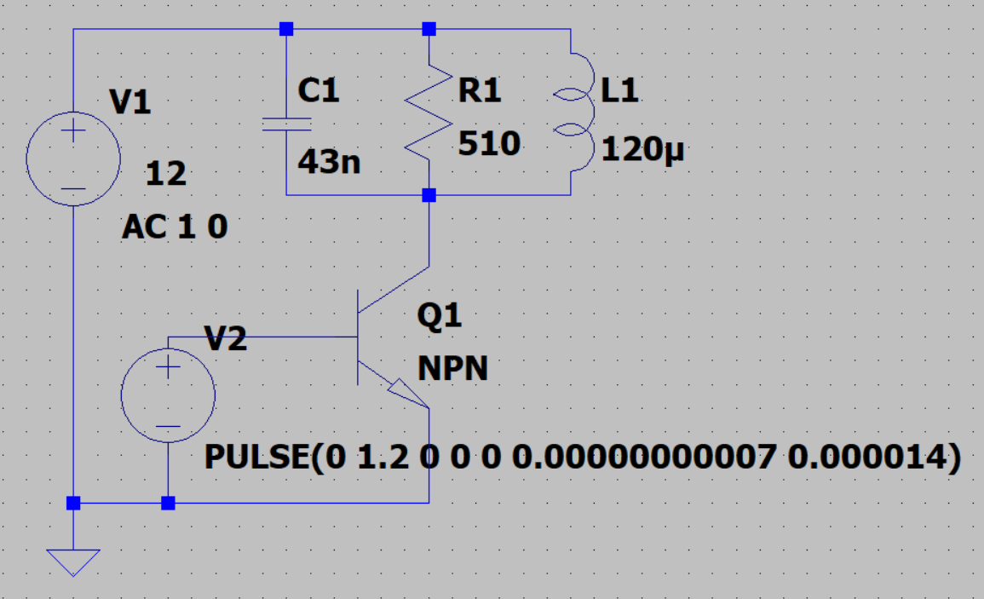

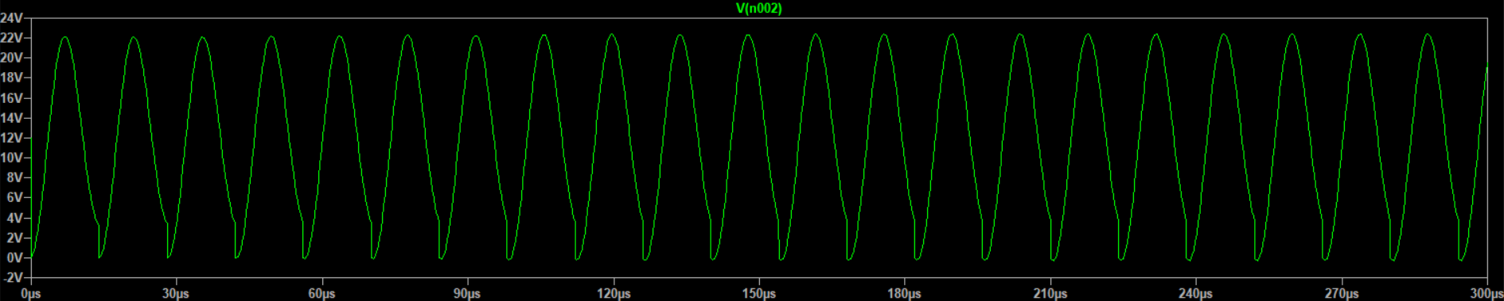

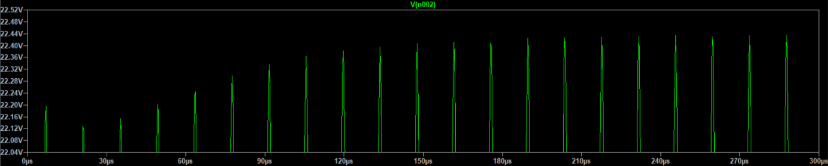

The waveform looks like a perfect sine wave, safe for the moment when the transistor injects the power. Furthermore there is a small dc offset of about 3.6V.

Bode:

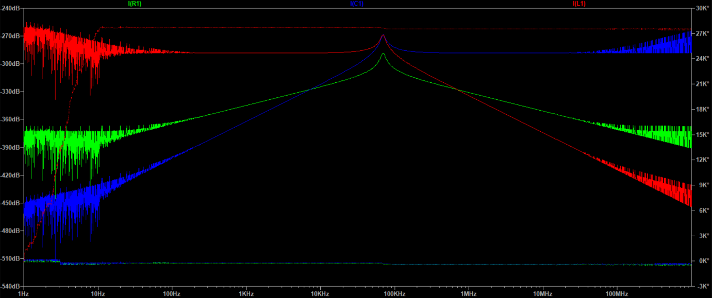

Hard to use phase change in k° range 🡪 software problems or non-pure-ac characteristics.

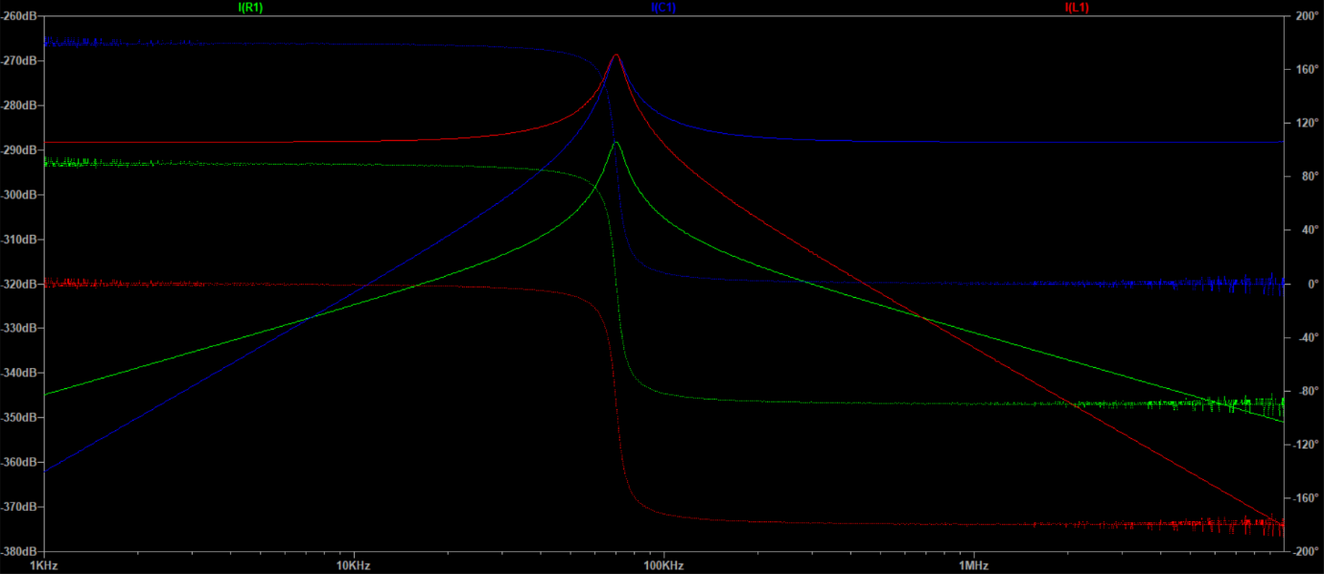

Current through elements R,C,L clear amplification peak at